Research in Dance and Physical Activity 2023 Dec;7(3):11-25
https://doi.org/10.26584/RDPA.2024.04.8.1.11
pISSN 2951-5904·eISSN 2951-4770

Tittle

Nameª∗
ª Professor (position), University (affiliation), Republic of Korea (nation)

ARTICLE INFO | ABSTRACT  The purpose of this study was to
Article history: (blank)

Keywords:
Convergence
Art
Physical activity
Dance

1. Introduction
In recent efforts to ~

2. Methods
2.1. Participants
The target population was ~

2.2. Procedure
The data were collected by research staff using self-reported questionnaires and face-to-face interviews. ~

2.3. Measures
Variables were measured using ~
Table 1. Characteristics

3. Results
The purpose of this study was to explore the ~.
To explore the components of ~.

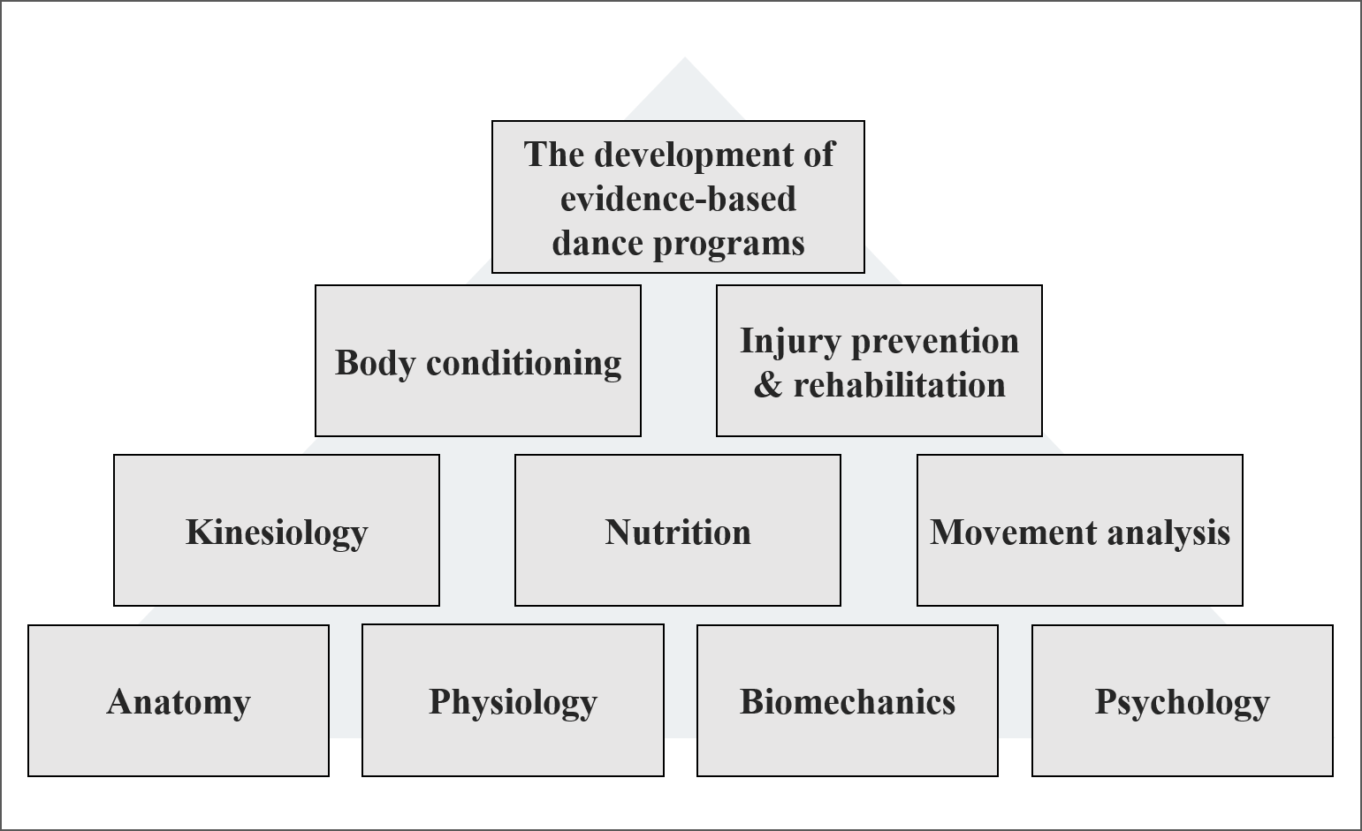
Figure 1. Pyramid-shaped curriculum

4. Discussion
The purpose of this study was to explore the

5. Conclusion
The aim of This study was to develop ~.

Acknowledgements
This research was supported by

References (APA style)
Cardinal, M. K., & Hilsendager, S. A. (1997). A curricular model for dance wellness education in higher education dance programs. Journal of Dance Medicine & Science, 1(2), 67-72.
Dunn, J. (1991). Dance science and dance medicine: an overview of the current scene. Medical Problems of Performing Artists, 6(2), 45-47.
Hayes, E. R. (1980). The education, training, and development of dance educators in higher education. Journal of Physical Education and Recreation, 51(8), 59-62.
Kim, H. S. (2005). A Study of the Prospect and the Academic Problems for Scientizing Dance. Official Journal of the Koeran Society of Dance Science, 11(0), 99-104.

∗ Correspondence author E-mail address:

